# Case Report

# National Gallery DC

Tracy’s iPhone [2012-07-15-National-Gallery]

Table of Contents

Case Report 1

National Gallery DC 1

Executive Summary 3

Details of Tracy’s iPhone 3

Relevant Evidence 3

Evidence relating to theft of valuable stamps 4

Evidence relating to Defacement of Museum Art 4

Plot Timeline 4

Email Content 4

SMS Message Content 4

Wi-Fi/GPS location information 5

Conclusion 5

## Executive Summary

On January 21, 2016, DigiTech Inc. was called in to assist with the National Gallery, Washington DC (NGDC) case involving the conspiracy associated with the theft of valuable stamps and defacing of museum of art at the NGDC.

* Tracy is a suspect in the above-mentioned conspiracy.
* As part of the investigation, Tracy’s iPhone was taken into custody.
* DigiTech Inc. was tasked with investigating evidence relevant to the above-mentioned conspiracy.

As described fully in this report, DigiTech, Inc. made the following findings:

We have used autopsy to filter thru Tracey’s iPhone to find the following findings eg. Device host name, OS version, Install time, Device serial#, ICCID, IMEI, Tracey’s phone number and email. I also filtered thru files to find further finding like other emails and phone numbers.

## Details of Tracy’s iPhone

-Device Host Name: Tracey iPhone 2

-OS version: iPhone OS 4.2.1 (8C148)

-Install Time: 6/6/2012 -12:03:28

-Device Serial: 86004482Y7H

-Integrated Circuit Card ID (ICCID) number: 89014103255195342366

-IMEI: 012021003735398

-Tracey’s Phone Number: +1 (703) 340-9661

-Tracey’s Email Addresses: [traceysumtwelve@gmail.com](mailto:traceysumtwelve@gmail.com),

-work email [tracy.sumtwelve@nationalgallerydc.org](mailto:tracy.sumtwelve@nationalgallerydc.org)

## Evidence to establish Personas

This section establishes aliases, phone numbers, emails addresses associated with each person, and relationships between each individual.

Tracy: Also alias is Coral

Phone Number: +1 (703) 340-9961

Email: [tracysumtwelve@gmail.com](mailto:tracysumtwelve@gmail.com)

Work email: [tracy.sumtwelve@nationalgallerydc.org](mailto:tracy.sumtwelve@nationalgallerydc.org)

Relationship: Accused

Pat: Also used the alias Perry

Phone Number: +1 (571) 308-3236

Email: patsumtwelve@gmail.com

Relationship: Brother/ Corrupt cop

Terry:

Phone Number: +1 (703) 829-6071

Email: -

Relationship: Daughter

Joe:

Phone Number: no number

Email: joe.sum.twelve@gmail.com

Relationship: Husband

Carry:

Phone Number: + 1 (202) 725-2124

Email: carrysum2012@yahoo.com

Relationship: Terry’s Friend

I was able to find emails, sms and phone numbers for the following people.

* Tracey, Carry, Pat, King(Kart) and Terry.

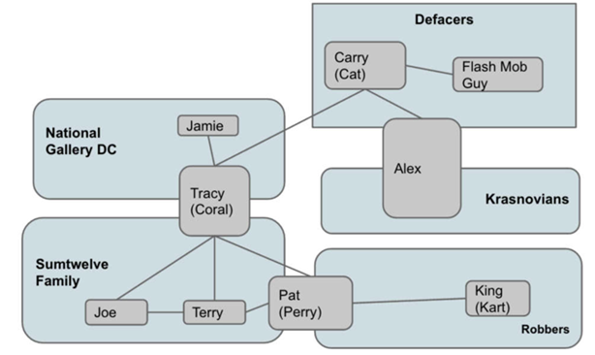

Equipment and Tool’s

Autopsy  
MD5 Hash  
SHA-256 Algo

### Evidence relating to theft of valuable stamps

This sub-section provides details regarding the evidence found as it relates to the theft of valuable stamps.

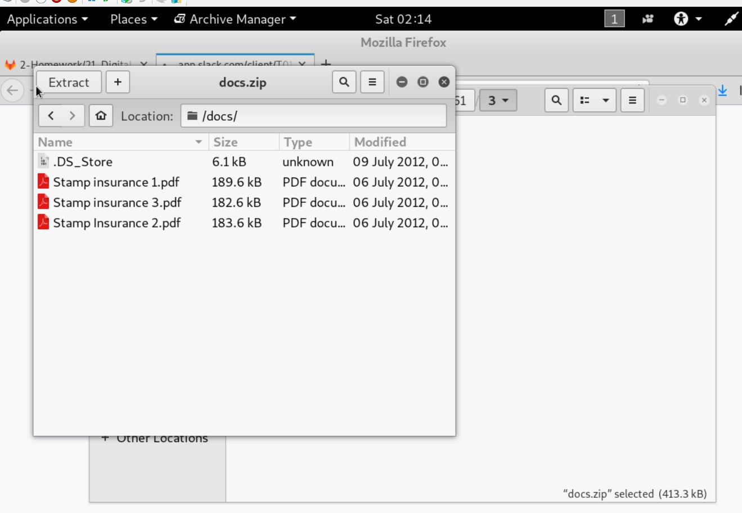

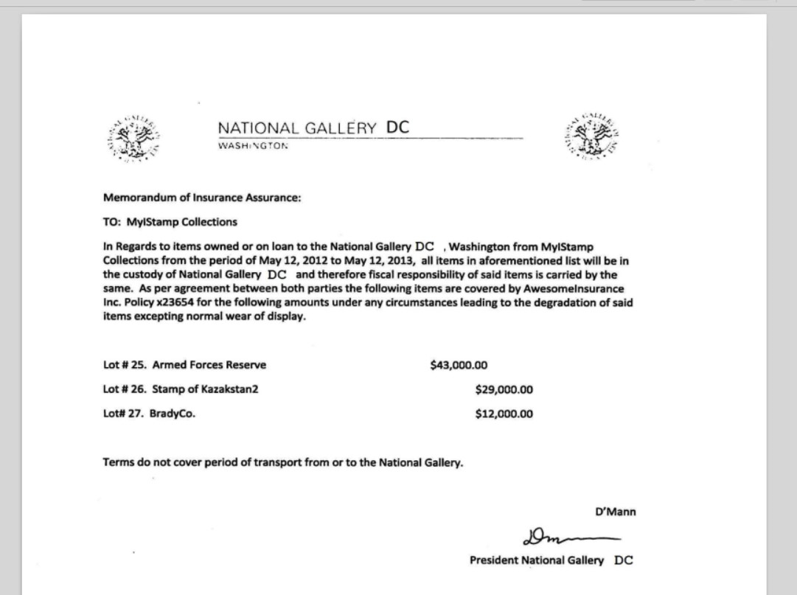

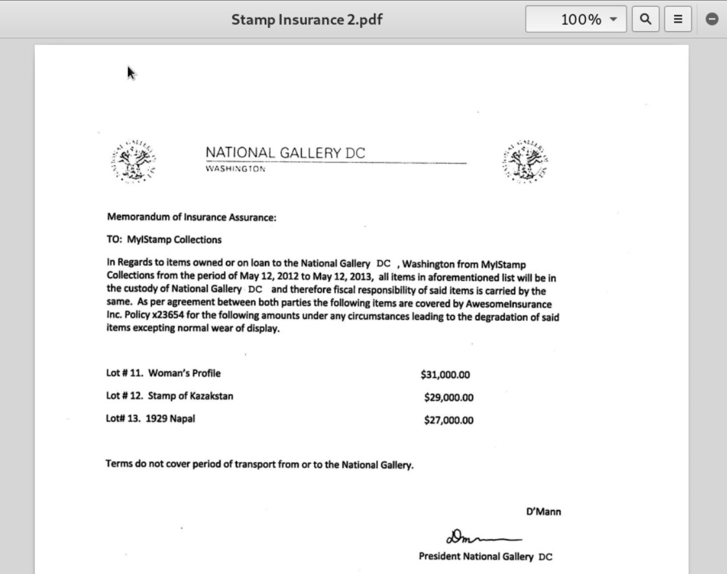

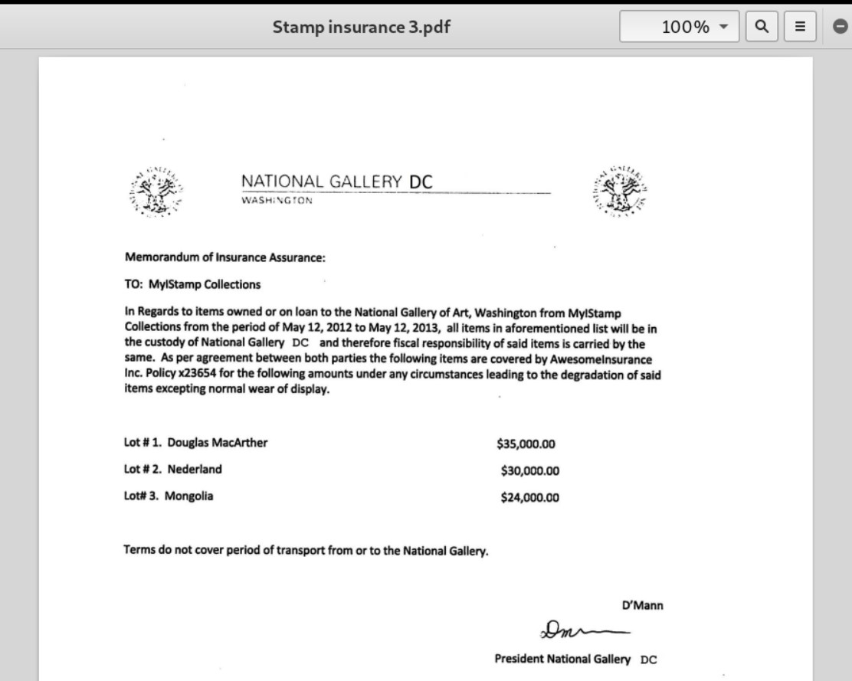

### 

### Evidence relating to Defacement of Museum Art

This sub-section provides details regarding the evidence found as it relates to the Defacement of Museum art.

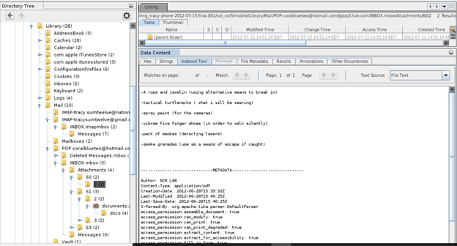

## Plot Timeline

06/07/2012 11:49:31

In two weeks from 06/07/2012 11:49:31, Tracey and her associates are planning a heist at the national gallery.

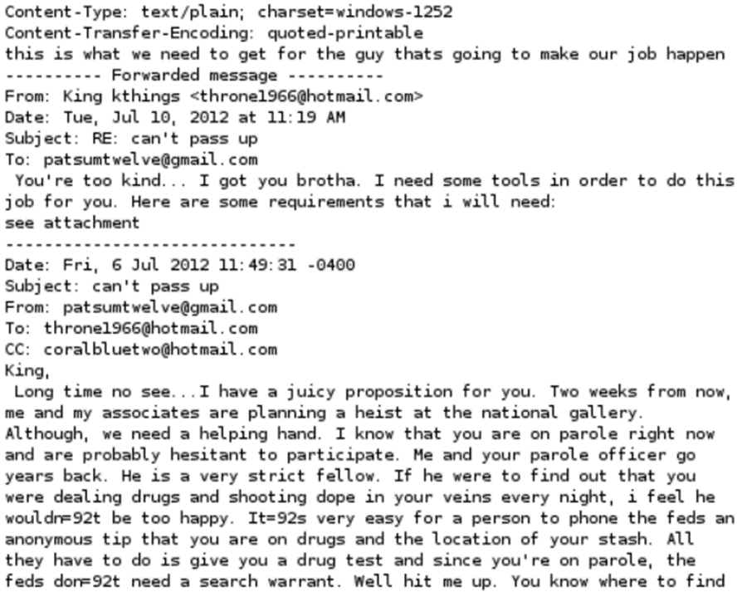

## Email Content

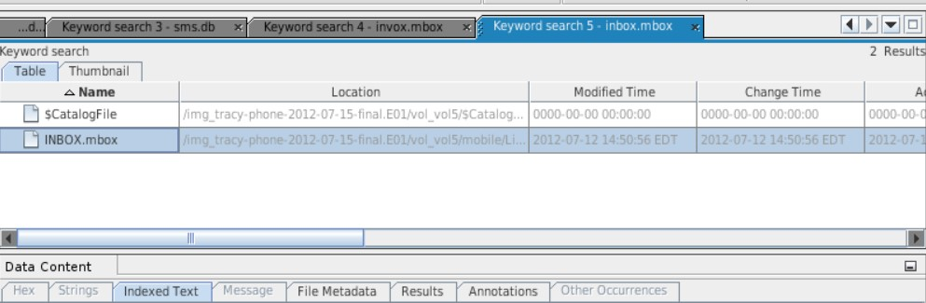

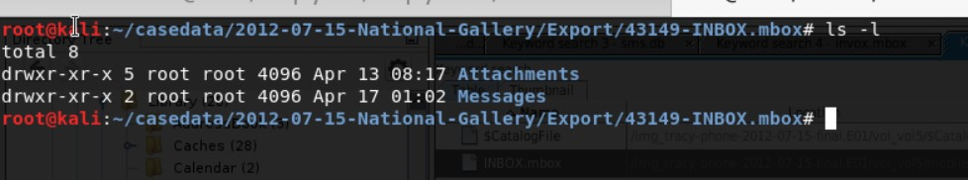

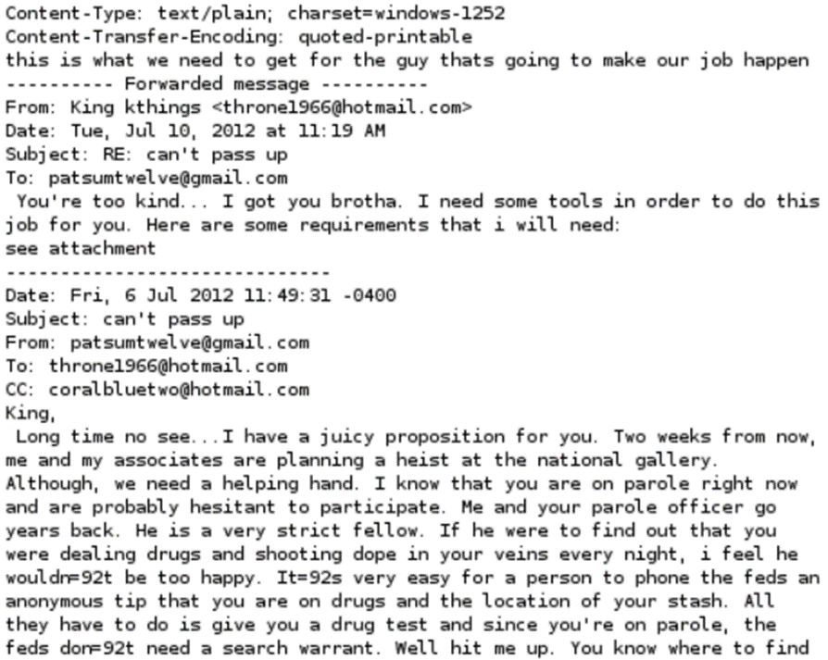

## SMS Message Content

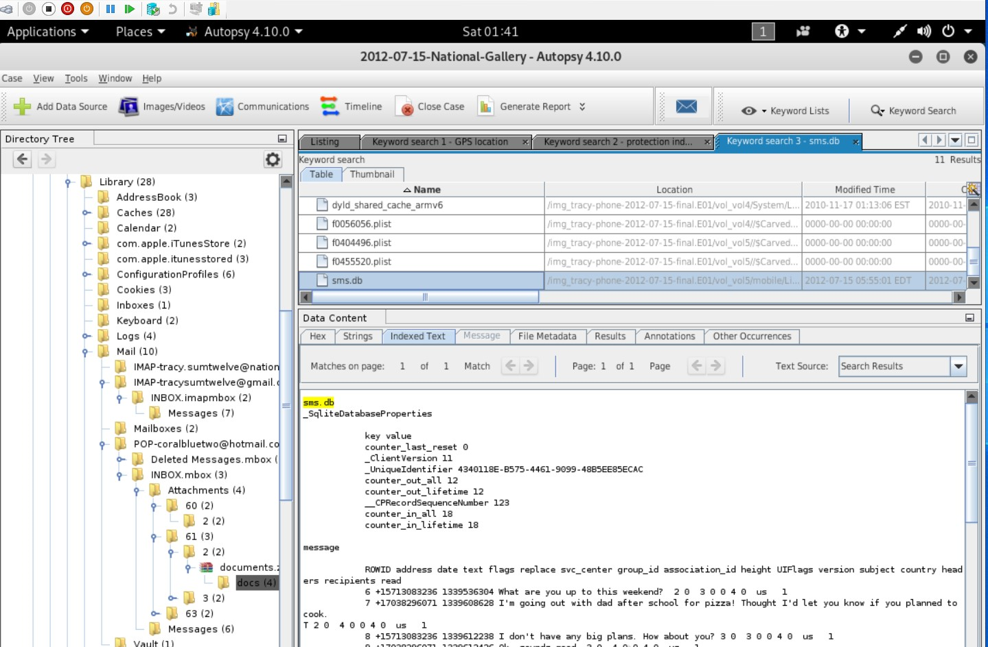

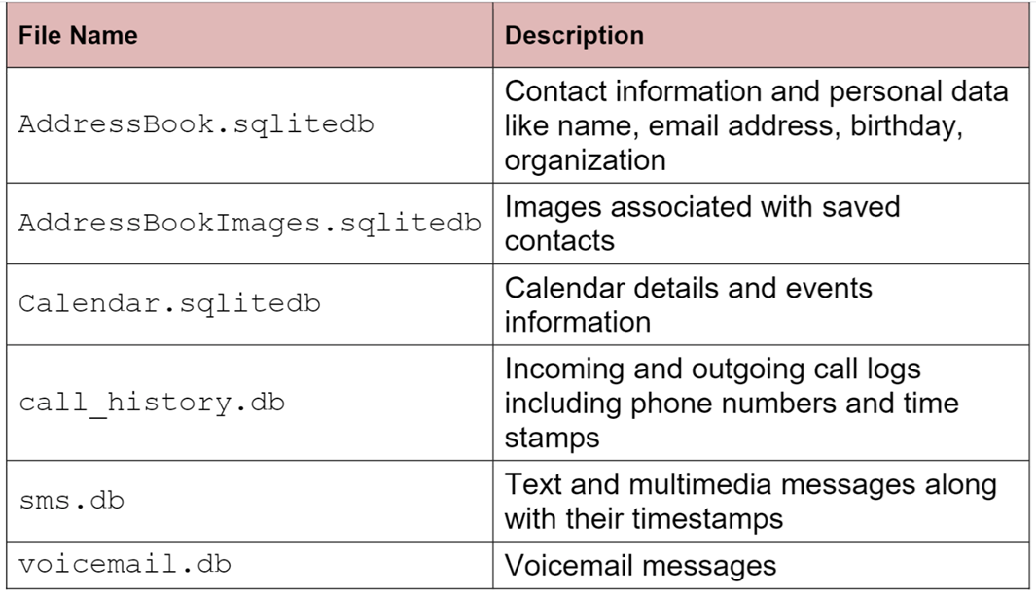

## Wi-Fi/GPS location information

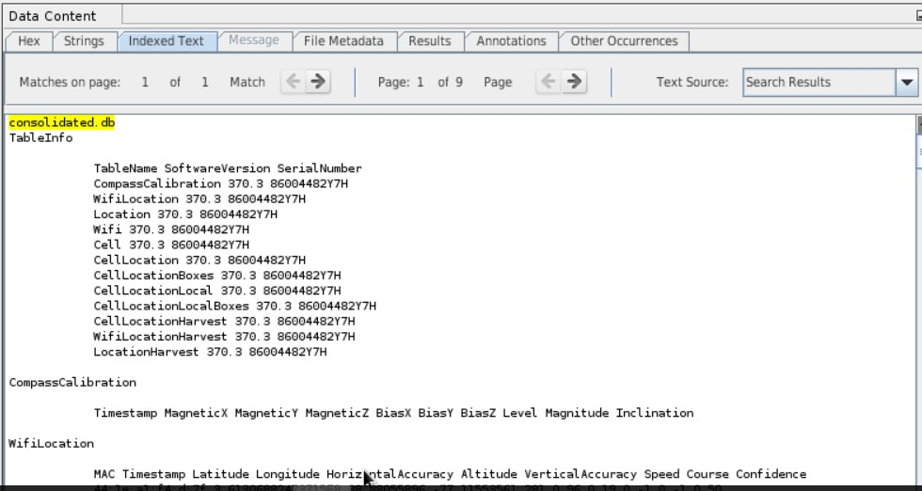

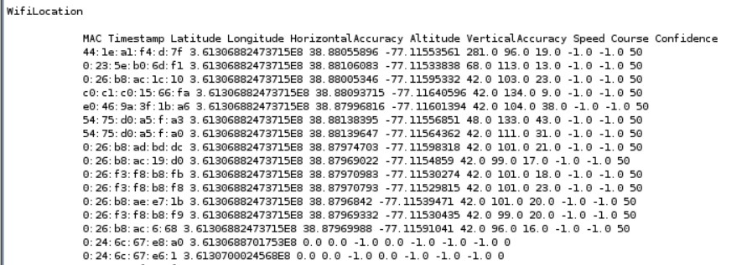

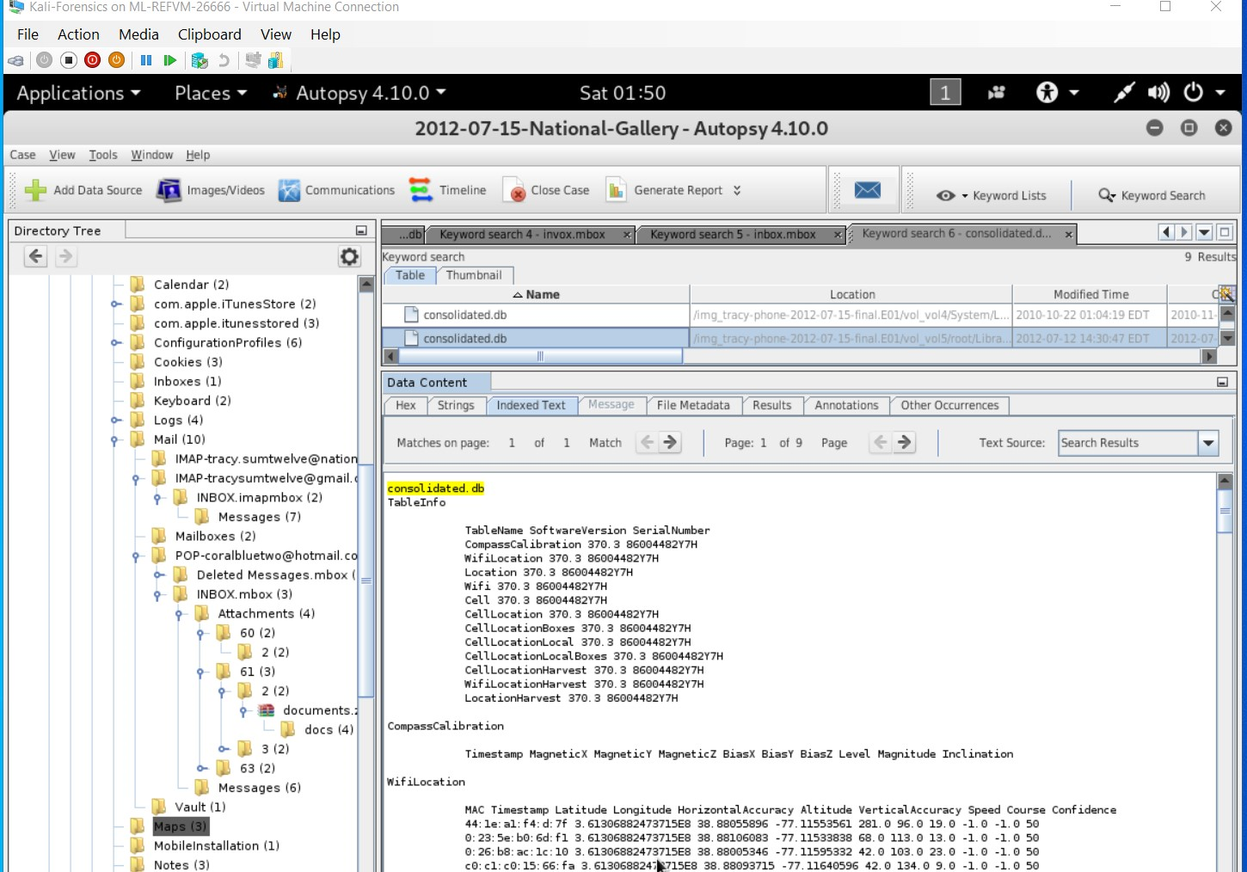

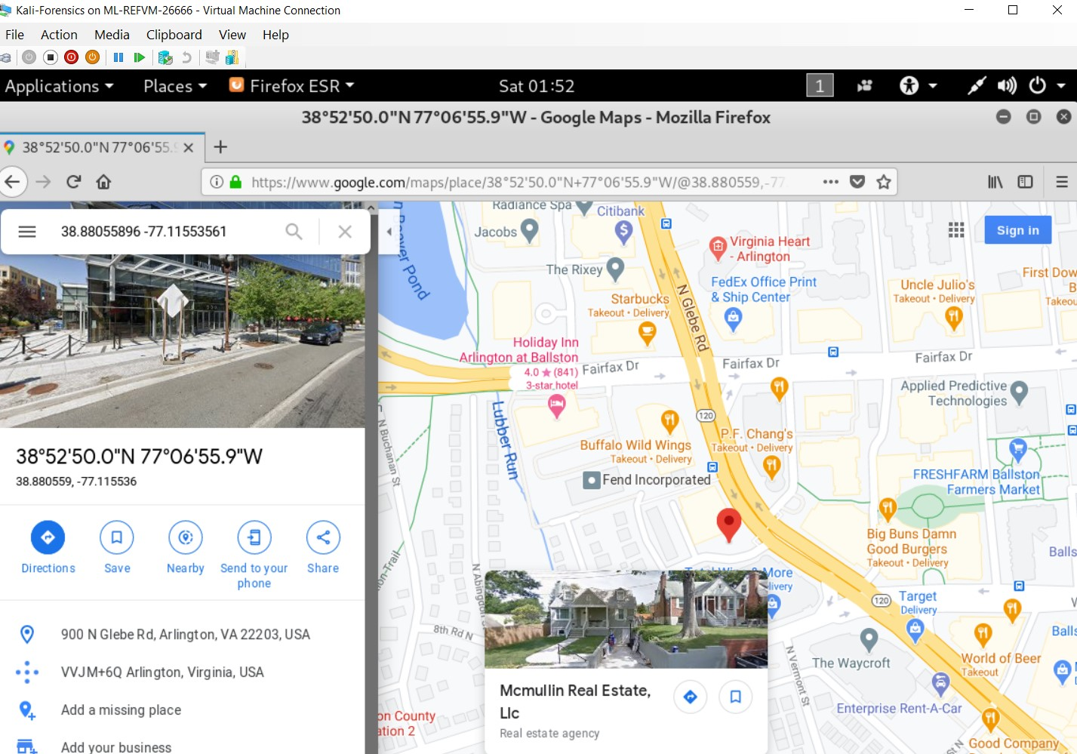

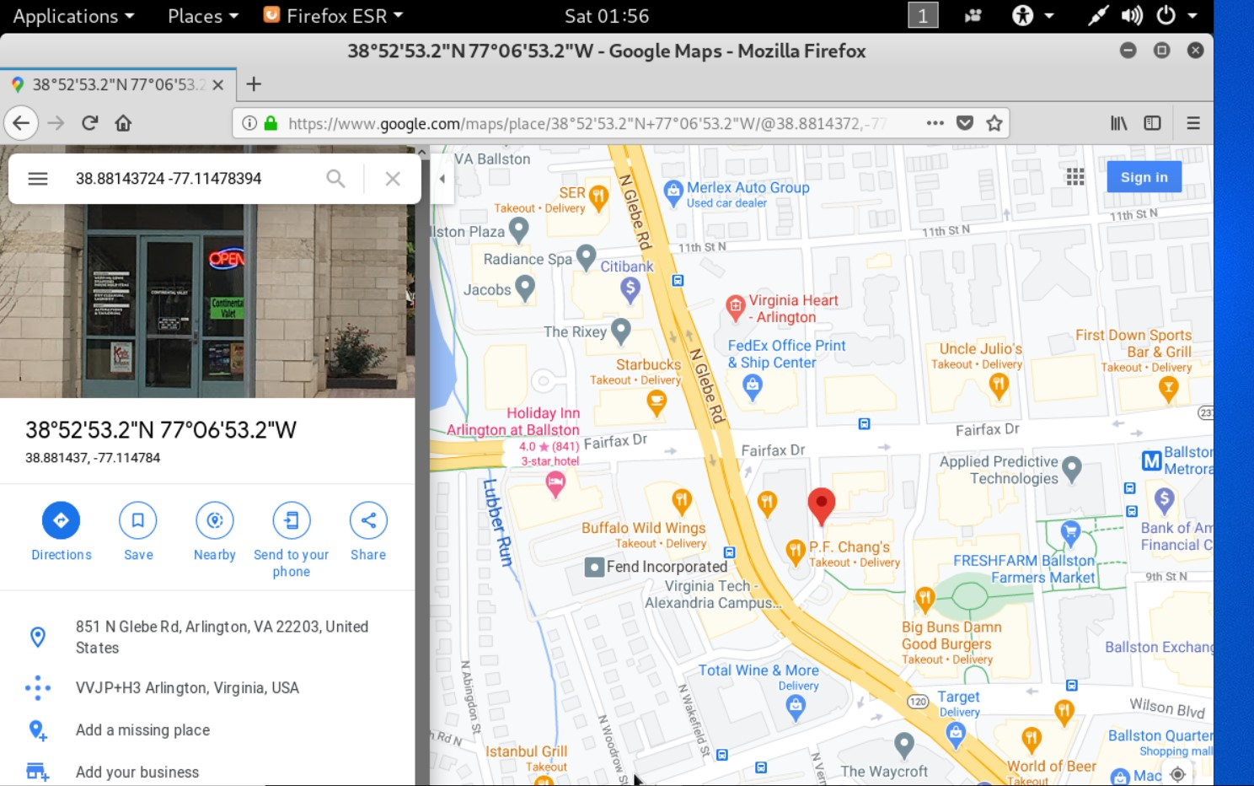

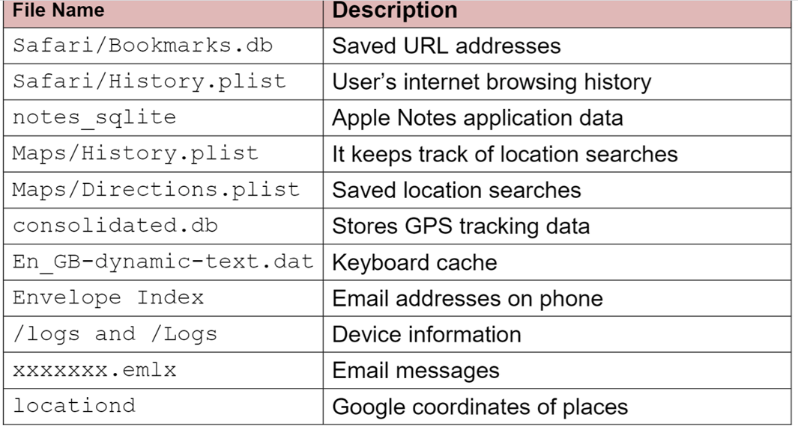

## Conclusion

Evidence found on Tracy’s iPhone indicated the following:

* Tracy used the alias Coral and Pat used the alias, Perry.
* The final finders were significant in finding out the plot that was getting organized to defacement the national gallery to steal a 9 lot of stamps worth $260,000. The following people were involved in the planning an organizing of this heist, Tracey- also alias Coral, Pat- also alias Perry, Terry, King (Kart) and Carry. I was able to find in emails and SMS in relation to the defacement of the national gallery. Which I also found deleted emails and SMS, but I was able to still retrieve them. On Tracey iPhone2 there was still data implementing the people accused of their involvement in the planning of the heist.

Which there is documents of the insurance papers with clear value of the stamps which Tracey should not have in her personal email account as they belong to the National Gallery, Using the file thru the Wi-Fi/ GPS was able to get the locations of the of Tracey movements which we can see the places she has visited.